Project No. | SCE99
Project Name | Extension of a heat map creation tool
R&D Classification | [ ] Preliminary Survey ( %)  [ ] Investigation ( %)  [ ] Feasibility R&D ( %)  [ ] Applied R&D ( %)  [✓] Applied Development or Applied Development Support (100 %)  [ ] Other (Improving R&D Env., Standardization, Follow up etc) ( %)
Project Type: | Type code is (e.g. A1,A2,A3,B1,B2,B3,C1,C2,C3,D1,D2,D3)  [ ]Research []Prototype [✓]In-house [ ]Commercial  [ ]System [ ]High-level Component [ ] Low-level Component
R&D Phase | [ ] 1.Early ( %)  [ ] 2.1 Trial & Error ( %)  [ ] 2.2 Final ( %)  [ ] 3.Wrap-up ( %)  [✓] 4.other (100%)
Internal/External R&D | [] Project internal to SRCB  [✓] External requested project – Request No.( )
Relationship to Product Costs | [ ] included in product cost
Project Period | (Starting Date) 2017/09/01 (Ending Date) 2017/12/31
Project Group | SEB-SRCB
Project Leader | Boyuan Huang （Staff ID:03149）
Planning section Person
Related Project | ICT BoZ project
Related Product |  | Release Date
Export Regulation | [ ] Not Checked [ ] Not Related [ ] Related (No: )
Total Person-Month | (Person-Months) 9 person-months

Approval Method | [ ] Documents Only [✓] Meeting :
Comments by Approver

[Background, Purpose]

Ricoh Europe has a warehouse in Bergen op Zoom (BoZ), Netherlands. ICT is applying our stereo cameras and a heat map creation tool to analyze human flow and to find possible problems in the warehouse. The system consists of 3 components: capturing RGB images and disparity images, recognizing and locating humans and objects (preparation tool), and creating and showing heat maps (heat map viewer).
It takes too much time to find possible problems, because the current heat map viewer cannot directly show pictures from a heat map.
a. The tool should be extended so that the pictures can be directly shown from a specified point in a heat map.
b. The current preparation tool is implemented as a batch program, which makes difficult for BoZ people to use the tool. A GUI that calls the current batch program is expected.

Extension of a heat map creation tool

[Summary Description] (Goal and sub-goals description)

The goal of Extension of a heat map creation tool is to extend the heat map creation tool.
- The recognition component creates compressed images, where each recognized human or object is surrounded by a rectangle. While showing a heat map, the system will allow a user to show the recognized images by clicking a point in the heat map.
- Current batch program for object recognition and coordinate translation shall be encapsulated under a GUI program. Any BoZ people who are not familiar with IT systems can run the program.

[Expected Outputs & Evaluation Method]
Source code,
Executable programs,
System design document,
Test report,
Installation manual,
User manual

[Interim Report Meeting or Release Meeting No.1] <yyyy/mm/dd>
(Summary)

N/A

[Interim Report Meeting or Release Meeting No.2] <yyyy/mm/dd>
(Summary)

N/A

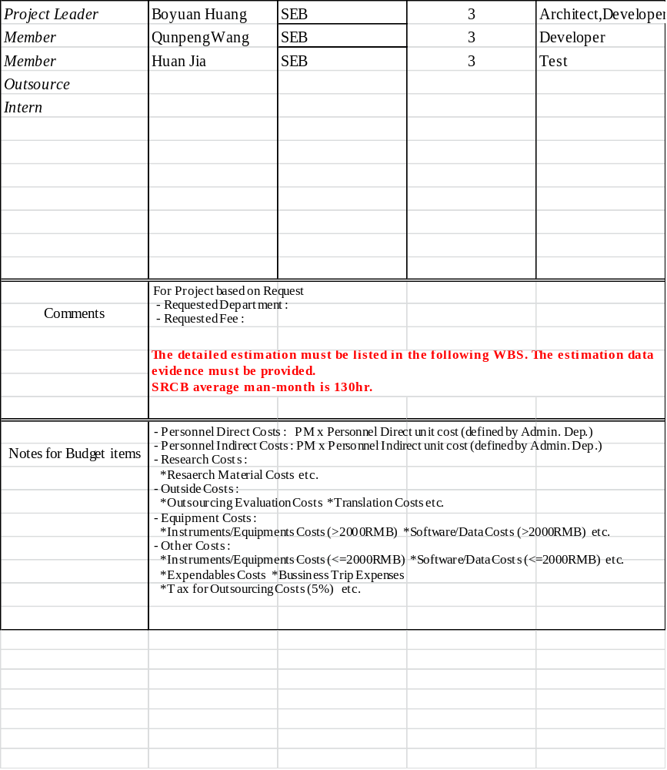

[Analysis of Current Situation and Goals] (Trends of market, R&D technology, competitors; in-house technology, its problems and goals etc.)

The BoZ project is using batch program ,that is

原始批文件程序工作不方便，picture display不方便
[Possible Future Competitors and Competitive Advantages] (including index for future technology, its current status of our company and competitors)

N/A

[Technical Aspects] (R& D policy)

This development will based on the rule of agile development.
[Organizational Aspect] (Responsibilities Assignment Matrix, including members in SRCB, Ricoh client and other related organizations ;)

 | Boyuan Huang | QunPeng Wang | Huan Jia
Project Planning | R
Preparation tool architecture | R | I
Preparation tool design | I | R
Preparation tool coding | R | R
Preparation test |  |  | R
Viewer design | R
Viewer coding | R
Viewer test |  |  | R

Quality Aspect (Quality policy, Metrics, Coding Rule, Change Control, Process Improvement ,KPT, GOA and other related SRCB standards)

采用基于TDD敏捷开发方式
[Risk Management] (Foreseeable Problems and Countermeasures; A risk list should be attached here.

Potential risk：
1 Human resource risk: The employee attended the project may resign from their work

2 High priority tasks: Some high priority task may jump into the tasks queue, which may postpone this project.

[Development Environment] |  | Development Environment |  | Target
 | Computer
 | Peripheral
 | Mandatory Hardware
 | Operating System | Win10 |  | Win10
 | Computer Language | C#,JavaScript,HTML
 | Tools | Visual studio
[Estimation or Goal]
 | Source code (steps) | [new] N/A  [modified] N/A | [total]  (=new+coef*mod)  N/A
 | Object code (KB) | N/A
 | Memory size (MB) | N/A
 | Response Time (sec) | N/A
 | Other non-functional aspects | (including precision, throughput, load, endurance, etc. if applicable)
[Software/Hardware incorporated into tech. output]
(Component, Module, Library, Open source etc.)

[Standard]

[Open Source Software (OSS)]
 | Use OSS or not? | [ ] Yes [✓] No
 | Which type of OSS will be used? | - When a user access to a web page which contains Java Script OSS, it makes one distribution of that Java Script OSS, and should follow “rules to 5”.  - Copy-left: source code required license other than GPL, such as LGPL, MPL, CDDL and other modified versions of MPL Permissive / academic licenses such as Apache, MIT, BSD are NOT copy-left and safe to use.  Apache license has patent clause which protect license holder such as Apache Foundation from patent law suit.
  Type of Project | Rules
  1. In-house Use | Keep the OSS check record
  2. Demo Program | - Rule to 1  - Do not copy and distribute the program. If needed, rent the whole system which includes the demo program and hardware.
  3. Tech. Transfer | - Rule to 1  - Use explicit and recordable methods (Email, Notes DB, etc) to make Ricoh side decide
  4. Providing SaaS or Server Side program | - Rule to 1  - Not allowed to use AGPL license OSS  - Watch for Java script. ⁽¹⁾
  5. Product | - Rules to 1 and 4  - Not allowed to use GPL license OSS  - Not allowed to make modification to weaker copy-left licenses OSS ⁽²⁾
 | Attach check list here | Attach an Excel file including OSS bill of materials (BOM) here.

No.1
[Company name] | [Product name]
[Specification]
[Price] | [Comments]

No.2
[Company name] | [Product name]
[Specification]
[Price] | [Comments]

No.1

[R&D Task]
Viewer
[Description, Goal, Policy, Methodology, Sub-task, Priority, Evaluation Method, Obstacles]
The purpose of the Viewer task is to build a web application，the new viewer shall be include the functionalities of the current viewer. And the new viewer shall be add picture jump function, the picture that contains recognized objects can be shown by clicking a position in the heat map.
[Achievement]  % | [Comments]

No.2

[R&D Task]
Preparation tools
[Description, Goal, Policy, Methodology, Sub-task, Priority, Evaluation Method, Obstacles]
The purpose of the Preparation tools task will develop a windows application with GUI. The application will replace the function of current command line tools.
[Achievement]  % | [Comments]

* ex) Module design, I/O Diagram in one page

*WBS & Gantt Chart must be listed here, it is the data evidence of human resource estimation.

Attach Schedule file including following items:
- R&D tasks
- Review plan for specification, design and source code with reviewers
- Patent related activities.

For example,
- 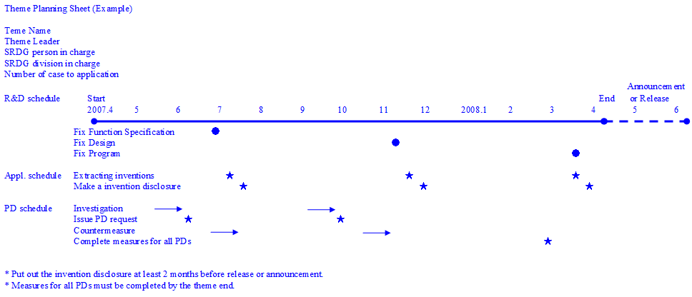

No. | Output Type | Technical Classification | Count  [Planned] [Result]
1 | Technical Memo
2 | Technical Report
3 | Design Document
4 | Technical Manual
5 | Technical Paper
6 | Ricoh  Technical Report
7 | Software Registration
8 | Exhibition
9 | Technical Transfer
10 | Patent application | [In default case, Planned number=0.17 * Total Person Months;  If not, please specify the reason ]
11 | Others

[Domestic Application (Competitors trend)]

[Oversea Application]

[Application Policy (with results at final report)]

[Patent Tree map]
[ ] undeveloped : deadline 20yy/mm/dd
[ ] developed : attach Tree Map file

[Patent Extraction/Brush up Meeting]

Plan
Patent Extraction Meeting
Brush-up Meeting

